R. Scott Clark is the President of the Heidelberg Reformation Association, the author and editor of, and contributor to several books and the author of many articles. He has taught church history and historical theology since 1997 at Westminster Seminary California. He has also taught at Wheaton College, Reformed Theological Seminary, and Concordia University. Read more» He has hosted the Heidelblog since 2007.

克拉克：「特浸派是改革宗的房屋占据者。」
「squatter」的意思是：非法占地者。R·司考特·克拉克用这个词描述那些自诩「改革宗」的浸派人士与浸派团体。
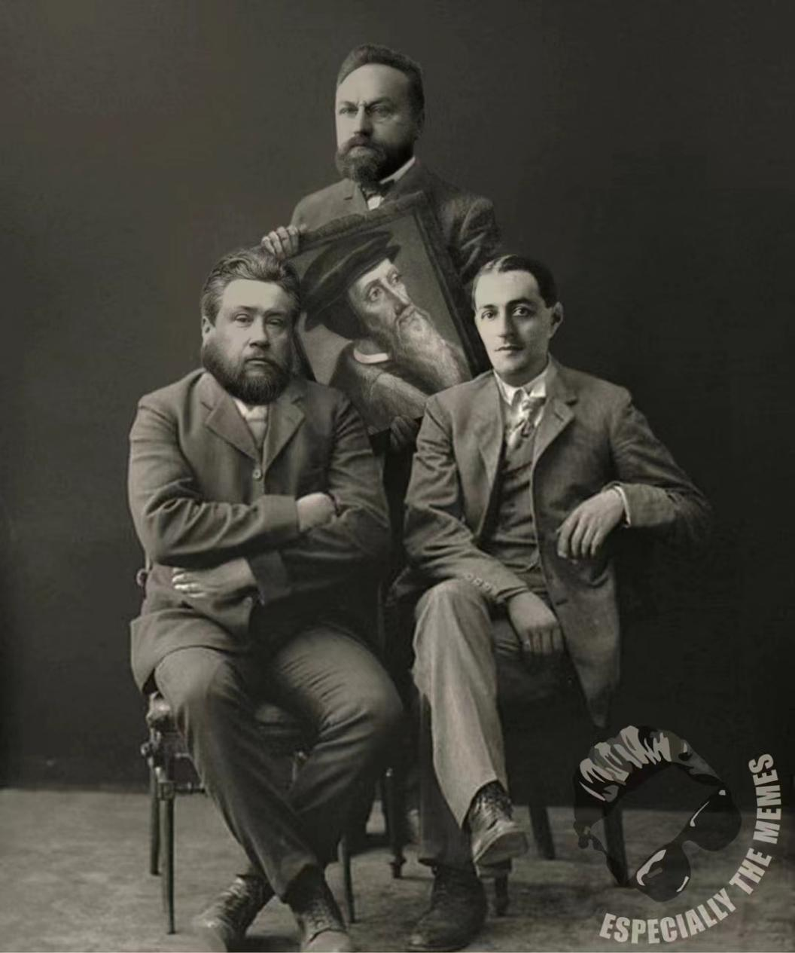
巴文克Herman Bavinck應該拿加爾文Jean Calvin的畫打下面兩個坐着的浸派假教師：司布真Spurgeon和亞瑟平克Arthur Pink。
浸派趁著改革宗的疏忽大意，闖入改革宗的地盤，擅自坐下侵佔，說自己是「改革宗」，假「改革宗」把真改革宗從自家擠走。

For some years I have complained about Baptist squatters in the Reformed house. These are those Baptists who insist on re-defining the adjective Reformed. As it turns out, however, this habit of squatting is not new at all. Indeed, one of the earliest examples occurred in 1680.

Squatters Then And Now
I use the metaphor of squatters because this is how those are described who take over someone else’s house (or attempt the same) when the homeowner is away and call it their own. When the homeowners are present, it is called a home invasion. To the degree the Reformed did not inhabit their own confessional house—they were away at war for the first half of the twentieth century—they left it vacant and squatters moved in. As we have tried to move back in, however, we have found the house crowded with competing accounts of what it means to be Reformed.
Where are these squatters, you say? Well, take a look at the number of Baptist publications and institutions who appropriate the adjective Reformed. There are Reformed Baptist schools. Reformed Baptist books, websites, etc. They are not hard to find. I was reminded this week of this problem when I received an email from one of my favorite booksellers notifying me of an edition of the Heidelberg Catechism: The Heidelberg Catechism: Credo Baptism Edition.
As a student of the catechism, I have seen many editions, including a modern Hebrew edition, but this one is rather different from the others. The editions to which I refer are all translations of the original Heidelberg Catechism as it was published by the Reformed Church of the German Palatinate in 1563. The edition that came to my attention, however, is a 2021 reprint of a 1680 Particular Baptist revision of the Heidelberg Catechism by Hercules Collins (1647–1702).
Two things stand out about this reprint. First, and most obviously, the subtitle: A Credo Baptism Edition. I think the more correct adjective would be Credo Baptist but even that adjective is a mongrel. It is a cute adjective which rhymes with common American pronunciation of paedobaptist meaning “baby baptizer.” Credo is the Latin verb (1st person singular, present active indicative) “I believe.” Thus, it is a modern, shorthand way of signifying “one who confesses believer’s baptism only.”
To state the obvious: A Baptist version of the Heidelberg Catechism is an oxymoron, a contradiction in terms. It makes no more sense and has no more relation to reality than would a Second London Confession (1689): A Paedobaptist Version. That document already existed. It is known as the Westminster Confession of Faith (WCF; 1647) and the differences between the WCF and 1689, as it is known among Baptists, are rather more profound than is often realized. I myself only gradually came to see how profound those differences are and I will endeavor to explain those differences in forthcoming essays.

A Herculean Task
The second thing to note is that this catechism is a republication of a work first published around 1680 by the Baptist pastor, Hercules Collins. His revision and publication of the Heidelberg under the title, An Orthodox Catechism tell us that the Particular Baptist habit of invading Reformed houses is much older than we might have thought. It is practically baked into the Particular Baptist movement.
Collins was Particular Baptist in England who helped to develop that tradition. He was an active author, publishing twelve books, who vigorously defended the distinctive convictions of the Particular Baptists. A modern, somewhat paraphrased version of his Orthodox Catechism is available online.

The introduction to the modern version says, in part,

This catechism, much like the 1689 Baptist Confession and the 1693 Baptist Catechism demonstrates the congeniality that these Baptist Puritans shared with their reformed, protestant contemporaries in the Christian faith. By utilizing the Heidelberg Catechism, Collins remains within the stream of the reformed tradition while expressing his own conviction of believer’s baptism.

This narrative is widely shared and deeply held among Particular Baptists. Is the Particular Baptist theology “congenial” to Reformed theology, piety, and practice? I think not—at least not as congenial as some Particular Baptists would have us think. The Reformed Baptist project entails significant revisions of Reformed theology which change our reading of redemptive history, the way we read the Bible, and our view of the church and sacraments, and our eschatology. Collin’s version of the Heidelberger is not “within the reformed tradition” as much as it marks a departure from it. Again, I offer as a thought experiment a version of the experiment I proposed in Recovering the Reformed Confession. Let us imagine that Collins were transported back 117 years, to the drafting of the to Heidelberg in 1562–63. Let us say that late in 1562 he made the same revisions that he published in 1680. How would the Palatinate theologians and pastors have responded? We do not have to guess.

The Reformed And The Baptists Contrasted
We know what they thought about the Anabaptist rejection of the continuity of the covenant of grace and their consequent rejection of infant baptism, with which Collins agreed. The Palatinate Church confessed:

74. Are infants also to be baptized?
Yes, for since they belong to the covenant and people of God as well as their parents, and since redemption from sin through the blood of Christ, and the Holy Spirit who works faith, are promised to them no less than to their parents, they are also by Baptism, as the sign of the Covenant, to be ingrafted into the Christian Church, and distinguished from the children of unbelievers, as was done in the Old Testament by Circumcision, in place of which in the New Testament Baptism is instituted.

This question and answer was a direct response to the Anabaptists and it stands as a response to all Baptists, including the Particular Baptists.
We confess that our children belong to the covenant of grace along with their parents. Why do we say that? We say it because God’s Word teaches it in Genesis 17:7, which we take as the paradigm for the covenant of grace. There are six proof texts in the 1563 edition of Heidelberg Catechism, the first of which is “Gen. 17.” The verse numbers with which we are so familiar were introduced by Stephanus in the late 1550s and were not yet in widespread use.
We confess that the children of believers belong to the covenant of grace because we view the nature of the covenant of grace differently from our Baptist friends. They typically see the covenant of grace as promised in the Old Testament but one coming into existence in the New Testament. In their view, the nature of the covenant of grace is such that no one but believers can be members and therefore only those who profess faith may be visibly entered into the church. In the Baptist view, there is only one way to relate to the covenant of grace.
According to the Reformed understanding of Scripture, there are two ways to relate to the covenant of grace: externally and internally (Rom 2:28; 9:6). We understand that the promise made in Genesis 17:7 is still in force, that it has not only never been revoked but was positively re-stated in Acts 2:39: “for the [Abrahamic] promise is to you and to your children…”
Baptism is for us as circumcision was for Abraham: a sign and seal of the one covenant of grace that was instituted under Adam (Gen 3:15), after the fall, administered under Noah (Gen 6:18), repeated and administered under Abraham (e.g., Gen 12; 15; 17), under Moses (e.g., Ex 2:24; 6:4–5; Lev 26:42), and under David and the prophets (e.g., Ps 105:8–9). We understand that the covenant of grace was not merely promised through types and shadows but that it was actually present, in, with, and under those shadows. We understand that Jesus led the Israelites out of Egypt (Jude v. 5; ESV) and “that rock was Christ” (1 Cor 10:4). We confess that the promise of Genesis 17:7 is still for our children. Thus, as the catechism indicates, unlike at least some Baptists, we do not regard our children as little reprobates and we do not speak of them that way. We regard them as children of the covenant of grace to whom promises have been made. We do not presume on those promises but we prayerfully trust the God who made them and we faithfully make due use of the means he has ordained by which he ordinarily brings his elect to new life and true faith.
Collins’ approach to the sacraments generally is different from the Reformed. Contrast the original Heidelberg Catechism on Q. 65 with Collins’ revisions.

COLLINS
Seeing then that only Faith Maketh Us Partakers of Christ and his Benefits, whence doth it proceed?
A. From the Holy Ghost, who kindleth it in our hearts by the preaching of the Gospel, and other ordinances (emphasis added), and confirmeth it by the use of the sacraments.

HEIDELBERG
Since then we are made partakers of Christ and all His benefits by faith only, from where comes this faith?
The Holy Spirit works faith in our hearts by the preaching of the Holy Gospel, and confirms it by the use of the Holy Sacraments.

The major difference here is that Collins added “and other ordinances” to the preaching of the gospel as the instrument by which Christ brings his elect to new life and true faith.
It might also be significant that Collins omitted the adjective “holy” from sacraments.
There are similarly minor but suggestive differences between Collins’ version of Q. 66 and the original version of Q. 66. The question is, “What are the sacraments?

COLLINS
They are sacred Signes, and Seals, set before our Eyes, and ordained of God for this cause, that he may declare and seal by them the Promise of his Gospel unto us, to wit, that he giveth freely Remission of Sins, and Life everlasting, not only to his all in general, but to everyone in particular that believeth (emphasis add), for that only Sacrifice of Christ which he accomplished upon the Cross.

HEIDELBERG
The Sacraments are visible holy signs and seals appointed of God for this end, that by the use thereof He may the more fully declare and seal to us the promise of the Gospel: namely, that of free grace, He grants us the forgiveness of sins and everlasting life for the sake of the one sacrifice of Christ accomplished on the cross.

Where the framers of the Heidelberg (chiefly Ursinus), after establishing that they are, in the second part of the catechism, preaching the gospel to believers, Collins is at pains to distinguish between believers and unbelievers in the church. Remember, the Baptist movement was born out of concern about unregenerate people in the visible church. Like the Congregationalists, they were going to be sure to achieve a pure visible church in this life.
Collins radical revisions of the Heidelberg become even plainer under the heading of Baptism. In Heidelberg 69 (Lord’s Day 26), the Reformed do not define baptism or a mode. The first thing to which we speak is the significance of holy baptism. The question asks, “69. How is it signified and sealed to you in Holy Baptism, that you have part in the one sacrifice of Christ on the cross?” and the answer says:

Thus: that Christ instituted this outward washing with water and joined therewith this promise: that I am washed with His blood and Spirit from the pollution of my soul, that is, from all my sins, as certainly as I am washed outwardly with water, whereby commonly the filthiness of the body is taken away.

Collins, however, defines baptism and stipulates the mode of baptism:

What is baptism?
Immersion or dipping the Person in Water in the Name of the Father, Son, and Holy Ghost, by such who are duly qualified by Christ.

Collins then turns immediately to the proper subjects of baptism:
Those who do actually profess Repentance towards God, Faith in, and Obedience to our Lord Jesus Christ.

The first proof text Collins gives is Acts 2:38. It is interesting that he does not cite vs. 39. He also cites Acts 8:38,39, and Romans 6:4. The omission of Acts 2:39 is surely significant.
We have considered the Reformed answer to the question, who are the proper subject of baptism and to the question of whether infants are to be baptized. Contrast that answer with Collins’:

Are no Infants to be baptized?
None by no means; for we have neither Precept nor example for Practice in all the Book of God.

Where the Reformed appealed to the Abrahamic pattern, Collins’ flatly repudiated it:

May not the infant Seed of Believers under the Gospel be baptized as well as the Infant Seed of Abraham under the Law was circumcised?
No; For Abraham had a Command then from God to circumcise his Infant Seed, but Believers have no Command to baptism their Infants [sic] Seed under the Gospel.

Collins was entirely unmoved by the Reformed appeal to the continuity of the substance and administration of the covenant of grace. Indeed, as he implied here, he had already argued, in effect, that the use of infant baptism is a denial of the rule of worship. To the question, “Doth the Scripture anywhere expressly forbid the Baptizing of Infants?” he answered, “It is sufficient that the Divine Oracle commands the baptizing of Believers, unless we will make ourselves wiser than what is written.” He appeals to the cases of Nadab and Abihu, who offered strange fire. This was a locus classicus for the Reformed defense of the rule of worship. For Collins it precludes infant baptism. He has an additional, if unstated rule: unless the command to include the infants of believers into the visible covenant community is repeated it is presumed to be expired. The continuity with the Abrahamic covenant is broken.
He made that explicit when, in answer to the question, “Seeing the Infants of Believers are in the Covenant of Grace with their parents, as some say, why may not they be baptized under the Gospel, as well as Abraham’s Infant Seed was circumcised under the Law?”
Before we look at his answer. The reader should note two things about Collins framing of the question. On the one hand, he has clearly read Reformed accounts of the continuity of the covenant of grace but just at the end of the question, he changes the terms by adding “under the Law.” This is a hint of the typical Particular Baptist conflation of the Abrahamic and Mosaic covenants. For the Reformed, the Abrahamic covenant was not “the Law.” The Mosaic covenant was, insofar as it was a republication of the covenant of works, “the Law.” Note also that he added the caveat, “as some say” regarding the including of infants in the covenant of grace.

Collins answered,
By the Infants of Believers being in the Covenant of Grace, it must either be meant of the Covenant of Grace absolutely considered, and if so, then there is no total and final Aposstacy of any Infant seed of Believers from the Covenant, but all must be saved then.
Or, 2. They must mean conditionally, on consideration that when they come to years of maturity, they by true Faith, Love, and Holiness of life, taking hold of God’s Covenant of Grace, shall have the Privileges of it. This being their fence, I then demand what real spiritual privilege the Infant-Seed of Believers, as such, have more than the Infant Seed of Unbelievers, if they live also to years of maturity, and by true Faith and Love take hold God’s Covenant? I further demand, whether the Seal of the Covenant do not under those considers belong as much to the Children of Unbelievers as to the Children of Believers?…

Collins continues at some length—apparently having given up on the idea of catechism—in his response to the Reformed view of the covenant of grace. One can see thus far that Collins’ has conflated the doctrine of election with the covenant of grace and rejected the Reformed doctrine of the external administration of the covenant of grace.
Like most Particular Baptists, he not only rejects the distinction between the substance and administration of the covenant of grace, he seems genuinely not to have been able to understand it. The privilege of the covenant of grace is to grow up in under its influence, to be a part of the external administration (as distinct from being utterly outside its administration). The child who grows up within the external administration not only receives the sign of the covenant but is catechized, is the subject of prayer, Christian instruction, and the life of the covenant community. He grows up hearing the law and the gospel.
Implicit in Collins’ objection seems to be the (Baptist) presumption that Collins knows who is and is not elect. He seems not to account for the judgment of charity whereby the church accepts the profession of faith of members until they demonstrate that they do not believe. We treat them as believers and we treat their children as the children of believers.
Does the Lord operate freely outside of the ordained means? Of course. Does that license us to ignore or to gainsay the divinely ordained means? Of course not.
He goes on to make the same errors that Baptists make today: demanding that if children are admitted to baptism why are they not admitted to the table. Collins seems not to have understood some basic elements of Reformed theology. Then as now, we did (and do not) admit infants to the table because baptism and the Lord’s Supper are two distinct sacraments, with distinct functions. Baptism is the sacrament of initiation and the Supper is the sacrament of renewal. Baptists typically conflate them, turning Baptism into the sign of renewal, and Collins is typical in this regard.
Collins recognized that there were spiritual and (typological) temporal promises to Abraham, but like many Baptists today, he ignored the New Testament’s interpretation of the significance of the land promise and like Baptists today, Collins also sought to cut off New Testament believers from Abraham. In short, as Baptists do, he tried to turn Abraham into Moses, which, according to the Reformed, Paul did not do.

Conclusions
Are the Particular Baptists “in the reformed tradition”? No. The consequence of redefining Reformed to admit the Baptists is that we must give up our reading of redemptive history (e.g., the continuity of the covenant of grace), our way of reading Scripture (i.e., our hermeneutic), our understanding of the nature of the covenant of grace, our view of the visible church, the internal/external distinction, our understanding the sacraments, our understanding of the promises God has made to believers and their children, the nature of the visible church, and, as we will see, our eschatology in favor of an over-realized eschatology that permeates the Baptist vision.

Part 2: 2LC v WCF (1)
https://heidelblog.net/2022/07/there-is-no-credo-baptist-heidelberg-catechism-or-why-hercules-collins-was-not-reformed/

Part 3: 1689 Vs. The Westminster Confession (2): Nature, Grace, and Revelation
https://heidelblog.net/2022/07/1689-vs-the-westminster-confession-2-nature-grace-and-revelation/

Part 4: 1689 Vs. The Westminster Confession (3): The Play-By-Play
https://heidelblog.net/2022/07/1689-vs-the-westminster-confession-3-the-play-by-play/

RESOURCES
How To Subscribe To Heidelmedia
The Heidelblog Resource Page
Heidelmedia Resources
The Ecumenical Creeds
The Reformed Confessions
The Heidelberg Catechism
Recovering the Reformed Confession (Phillipsburg: P&R Publishing, 2008)
Why I Am A Christian
Support Heidelmedia: use the donate button
Resources On Defining Reformed
Engaging With 1689
In, With, And Under
One Important Difference Between The Reformed And Some Particular Baptists: God The Son Was In, With, And Under The Types And Shadows
An Intramural Baptist Debate That Illumines The Profound Differences Between Baptist And Reformed Theology, Piety, And Practice
Dispensationalism’s Millennial Memorial Sacrifices: A Regression To Types And Shadows
Resources On The Unity Of The Covenant Of Grace
Resources On The Republication Of The Covenant Of Works
Online Resources on Infant-Baptism
On Being Reformed: Debates over a Theological Identity (Christianities in the Trans-Atlantic World)
Recovering the Reformed Confession
Resources On The Role Of Abraham In Redemptive History
Video: The Abraham Paradigm
Tracing The Paradigm Shift: Two Ways Of Being In The Covenant Of Grace

https://heidelblog.net/2022/07/there-is-no-credo-baptist-heidelberg-catechism-or-why-hercules-collins-was-not-reformed/

